Detailed Explanation of Power BI Visuals with Graphs

Product by Sales and Profit Visuals
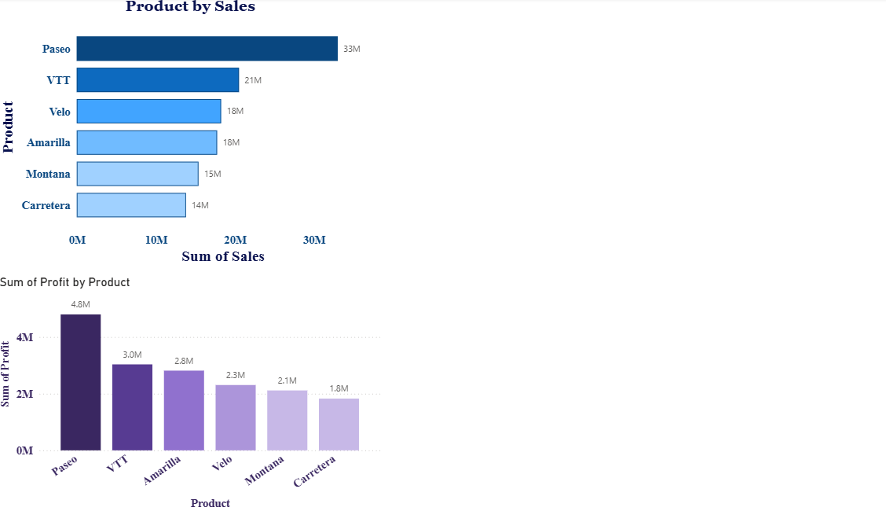
Here, two bar charts are created in Power BI to visualize the relationship between 'Product', 'Sales', and 'Profit'.
1. The first visual (top) shows 'Product by Sales':
- Visualization Type: Horizontal bar chart.
- Axis: Product.
- Values: Sum of Sales.
- The bars are sorted in descending order, showing 'Paseo' with the highest sales (33M) and 'Carretera' with the lowest (14M).
- A title 'Product by Sales' is added above the visual.
2. The second visual (bottom) displays 'Sum of Profit by Product':
- Visualization Type: Vertical column chart.
- Axis: Product.
- Values: Sum of Profit.
- The bars are colored in a purple gradient format, representing different profit magnitudes.
- Paseo again has the highest profit (4.8M), while Carretera has the lowest (1.8M).
3. Both visuals effectively show that Paseo leads in both sales and profitability.

Difference Between Stacked and Clustered Charts
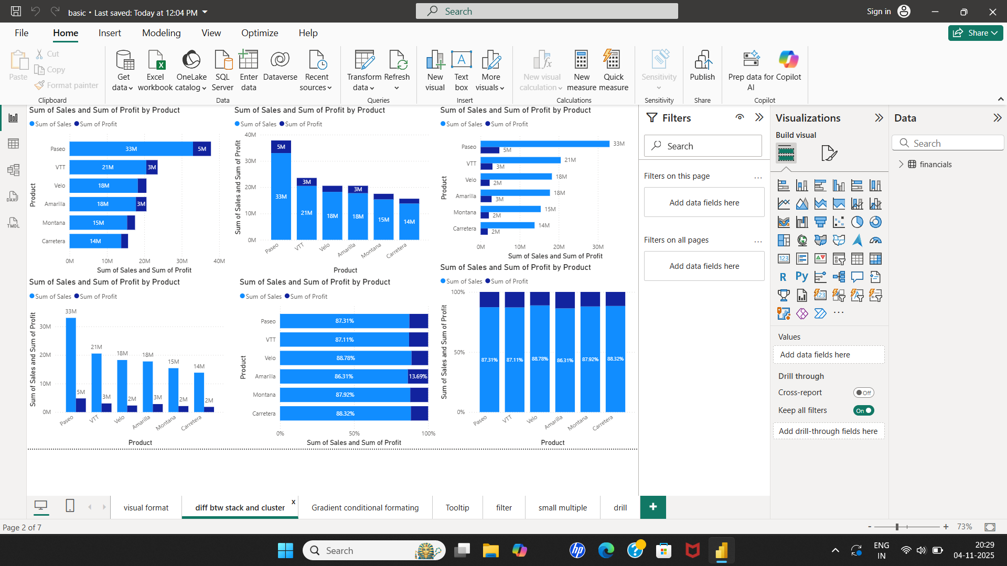
This graphs compares different types of bar and column charts for 'Sum of Sales' and 'Sum of Profit' by 'Product'.
1. Six different chart types are displayed, each comparing Sales and Profit:
- Clustered Bar Chart: Shows Sum of Sales and Sum of Profit side by side for each product.
- Clustered Column Chart: Displays the same comparison but vertically.
- Stacked Bar Chart: Combines Sales and Profit values into one bar per product.
- Stacked Column Chart: Combines Sales and Profit in vertical form.
- 100% Stacked Bar Chart: Shows proportional (percentage-based) contribution of Sales and Profit for each product.
- 100% Stacked Column Chart: Displays proportional data in a vertical form.
2. Each chart uses the same fields:
- Axis: Product.
- Values: Sum of Sales and Sum of Profit.
3. These visuals demonstrate how data representation changes depending on the chosen chart type.

Gradient Conditional Formatting and Additional Visuals
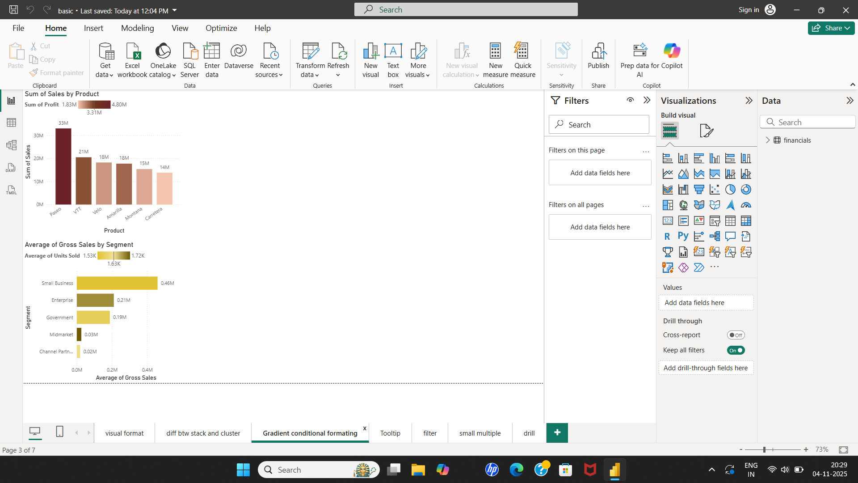
This graph highlights the use of gradient color formatting and additional analytical visuals.
1. The first visual at the top ('Sum of Sales by Product'):
- Visualization Type: Column chart.
- Axis: Product.
- Values: Sum of Sales.
- The bars are formatted using gradient colors ranging from light to dark brown to represent different profit values.
- A secondary value (Sum of Profit) is also displayed for each bar.
2. The second visual ('Average of Gross Sales by Segment'):
- Visualization Type: Horizontal bar chart.
- Axis: Segment.
- Values: Average of Gross Sales and Average of Units Sold.
- The chart uses yellow-toned gradient formatting.
- The segments include Small Business, Enterprise, Government, Midmarket, and Channel Partner.
- Small Business shows the highest average gross sales (0.46M), while Channel Partner is the lowest (0.02M).
3. These visuals apply conditional formatting and aggregation functions (SUM, AVERAGE) to provide deeper insights.

